Meet the Team
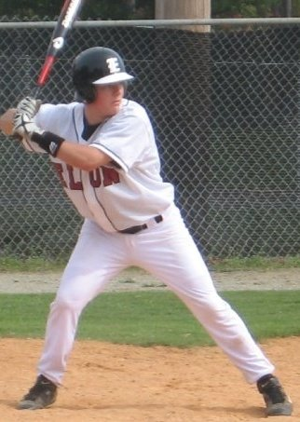
Jake Schoenfeld
Class Year:
Senior - 2012

Hometown:
Baltimore, MD

Major(s):
Accounting and Finance

Position(s):
C, Utility

Nickname:
El Diablo

Favorite Club Baseball
Experience:
Spring break trip to FL sophomore year beating two top 25 teams.

Plans After College:
Working for PWC as an assurance associate in Baltimore

Best Advice received:
PBDBSSFC

Spring Season Underway!

The spring season has begun for the Elon Club Baseball team. First games against Loyola Maryland – a division II club baseball team took place on February 18th. Two Saturday games were played on Elon’s Campus with the game Sunday getting snowed out. Only in North Carolina can you have 70 degrees with sun one day and 30 degrees with snow the next.
The two Saturday games were split one win apiece. The games were not official as players also served as umpires for these games.

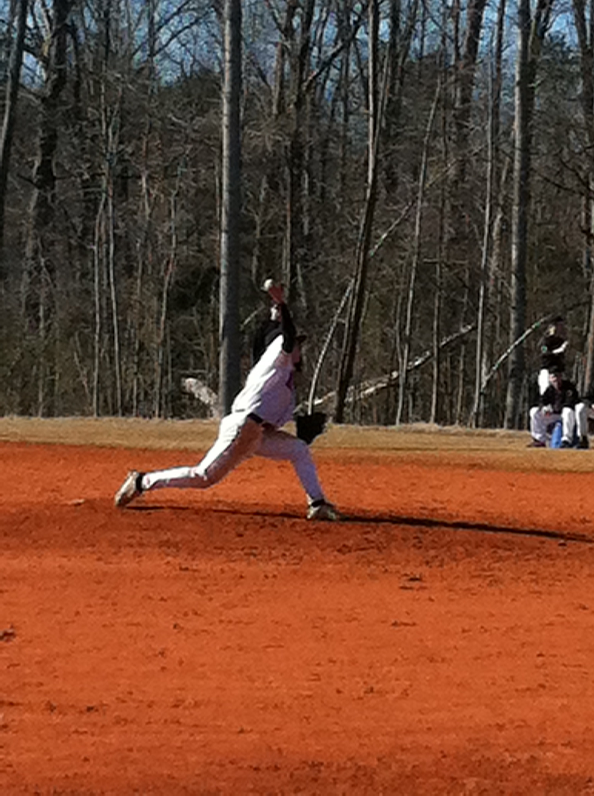
The first conference games were also played on Elon’s campus Sunday February 26th with the East Carolina Pirates as the opponents. Ranked number one in the nation for club baseball, they took both Sunday games against Elon. A 2-0 loss and a 5-0 loss were the results of the double header. Saturday’s game was rained out. Senior Jay Struck got the start in game one pitching an excellent complete game, holding arguably the best hitting team in the nation to a quick run in the top of the 1st and only one more in the 7th.

Senior catcher Jake Schoenfeld commented that “It’s unfortunate the we lost both games; we played well as a team especially not having been able to practice as much as we would have liked. Our performance is nothing to hang our heads about.”
Brian Magna ’14 pitching against ECU

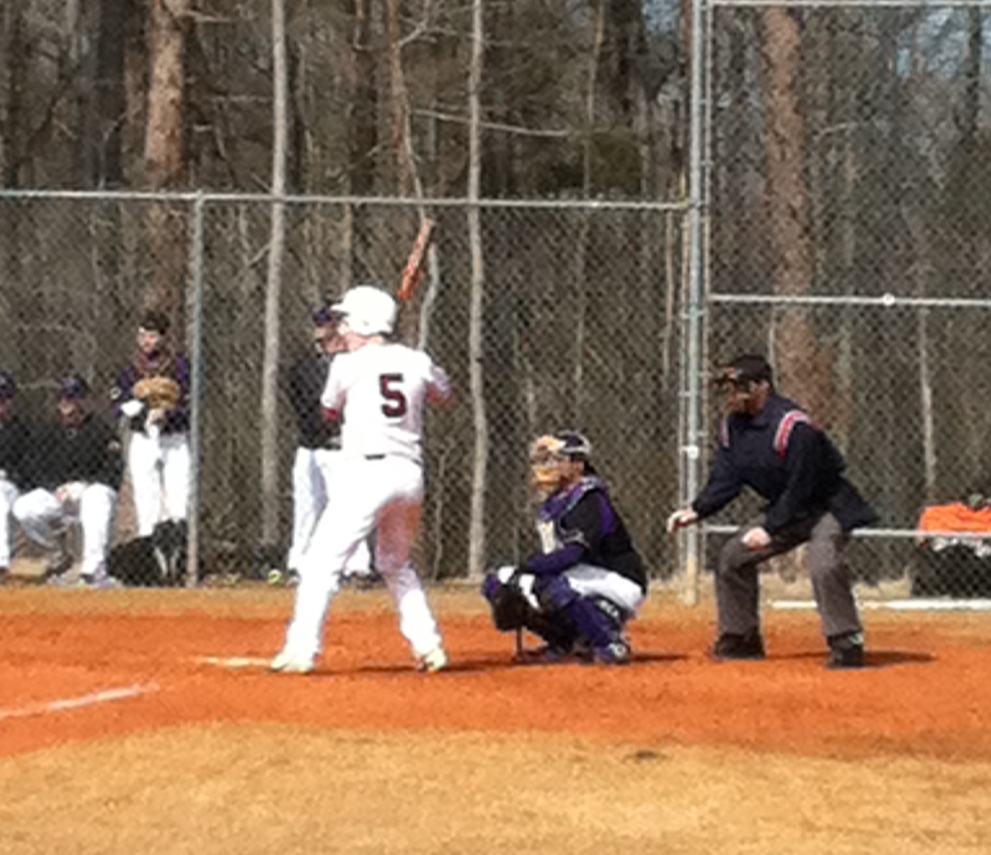
Club Baseball President and senior pitcher Aaron Moger on the series against East Carolina - “The future is still really bright for the team. We stuck with the best in the country for fourteen inning and one or two big hits and we could have been 2-0 right now. With consistent practice and hard work there is no reason why we can’t make the playoffs this season.”

Sophomore Brian Magna got his first start of his Elon career against ECU. He threw an excellent game though Elon’s offense couldn’t get much going. ECU pitcher Derek Carlyle received NCBA conference pitcher of the week for his performance again Elon helping the Pirates stay a perfect 8-0 on the spring season.
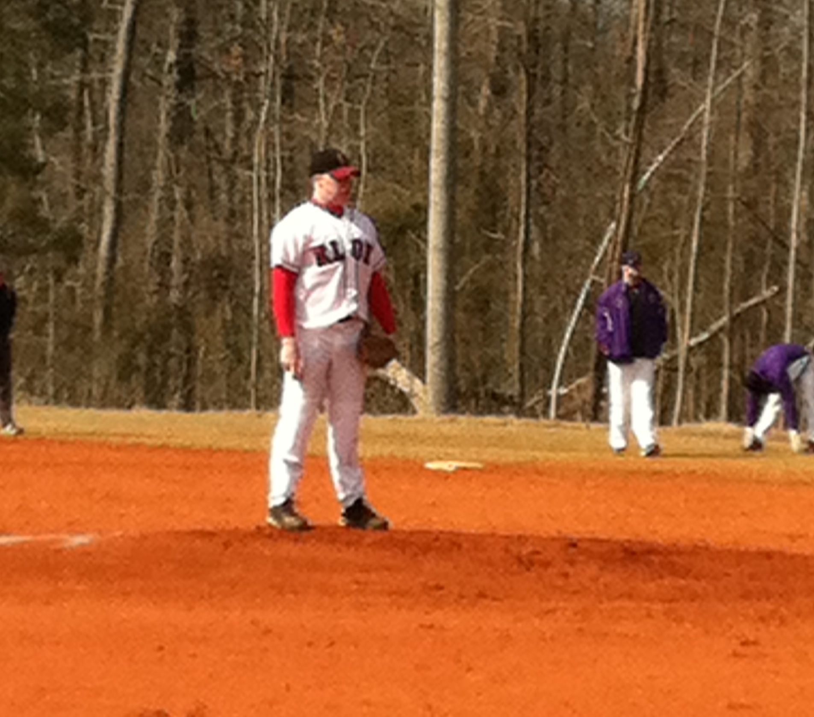

Ben Koffel ’15 at bat against ECU

The team looks toward their next series against Wake
Forest University the first weekend of March.
Then 12 players will head to Tampa for the NCBA Spring
Training Showcase during the week of March 18 – 24.

By Steven MacDougall ‘12
Jay Struck ’12 pitching against ECU

Team Notes:

Pictures and updates from the first few series have been posted to the website along with updated standings. To donate to the team please visit http://euclubbaseball.weebly.com/donations.html
We appreciate all donations to the team. For an extended interview with Jake Schoenfeld see our website http://euclubbaseball.weebly.com/interviews.html
You can also check out the conference website at http://www.clubbaseball.org/conf.asp?cid=70 to see updates on all the teams in the Mid Atlantic South Conference.
For more information about the team contact team president: Aaron Moger (amoger@elon.edu)
or visit out our website: euclubbaseball.weebly.com

